**Step 1. Travel info:**

1.1 **Policy Type**:

UI:

\openunderwriter\database\content\liferay\Liferay.sql

**INSERTINTO** `**layoutfriendlyurl**` **VALUES** ('dfe72d2f-92d8-4c8d-87da-f5f591538185',72750,72709,10157,10436,'Adam OpenUnderwriter','2014-10-02 14:52:51','2014-10-02 14:52:51',72749,0,'/get-a-quote','en_US');

INSERT INTO `**layout**` VALUES ('b2bd1bf7-8f1c-4480-8b9c-626aaaea3866',72749,72709,10157,0,'','2014-10-02 14:52:51','2017-10-20 21:16:38',0,5,0,'<?xml version=\'1.0\' encoding=\'UTF-8\'?><root available-locales=\"en_US\" default-locale=\"en_US\"><Name language-id=\"en_US\">Get a Quote</Name></root>','<?xml version=\'1.0\' encoding=\'UTF-8\'?><root available-locales=\"en_US\" default-locale=\"en_US\"><Title language-id=\"en_US\">OpenUnderwriter Demo - Quote</Title></root>','','<?xml version=\'1.0\' encoding=\'UTF-8\'?><root available-locales=\"en_US\" default-locale=\"en_US\"><Keywords language-id=\"en_US\">OpenUnderwriter, demonstration, insurance, open source, software</Keywords></root>','','portlet','layout-template-id=1_column\nsitemap-changefreq=monthly\nsitemap-include=1\nlayoutUpdateable=true\ncolumn-1=56_INSTANCE_HDvG99Opvkjo,quotation_WAR_pageflowportlet,56_INSTANCE_uhSsOxNYNCmB\n',0,'**/get-a-quote**',0,0,'classic','','','','',4,'',0,'');

+ Browser => Network

\openunderwriter\demo-product-loader-hook.war\src\Product\AIL\Demo\TravelPlus\PageFlows\**QuotationPageFlow.xml**

DB Entities:

SQL:

1.2 **Destination**:

DB Entities

SQL:

**Step 2. Select Packages:**

DB Entities

SQL:

**Step 3: Contact detail:**

+ submitted from “Buy” button

SQL:

**Diagrams:**

1. Activity diagram (from step 1 to step 3)
2. Sequence diagram (from step 1 to step 3)

**DB Entities for:**

1. Insured
2. Product
3. Package

Notes: Contact detail is **master**, List of travelers is **child**.

Screens:

<http://localhost:8080/web/travelplus/get-a-quote>

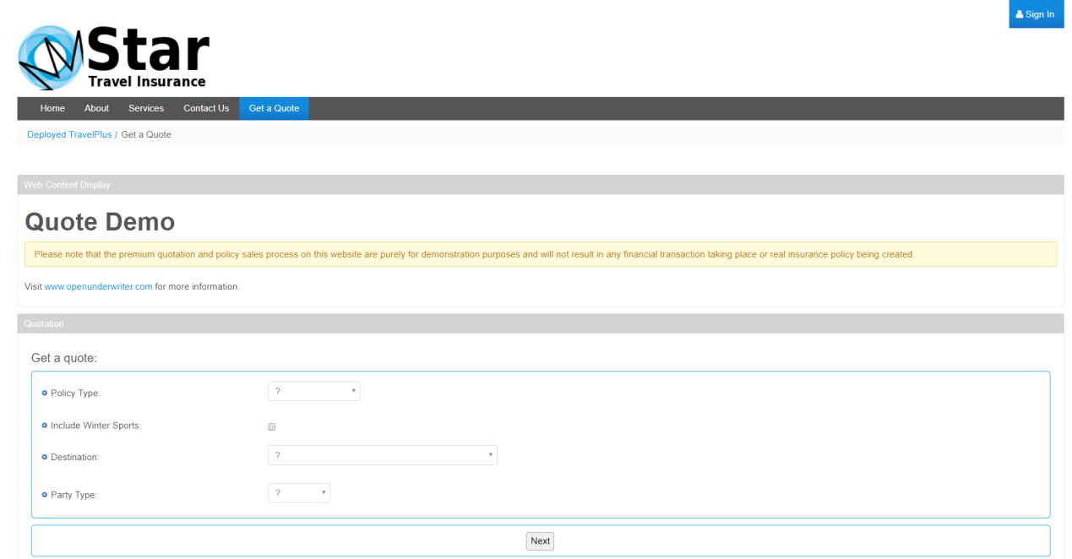

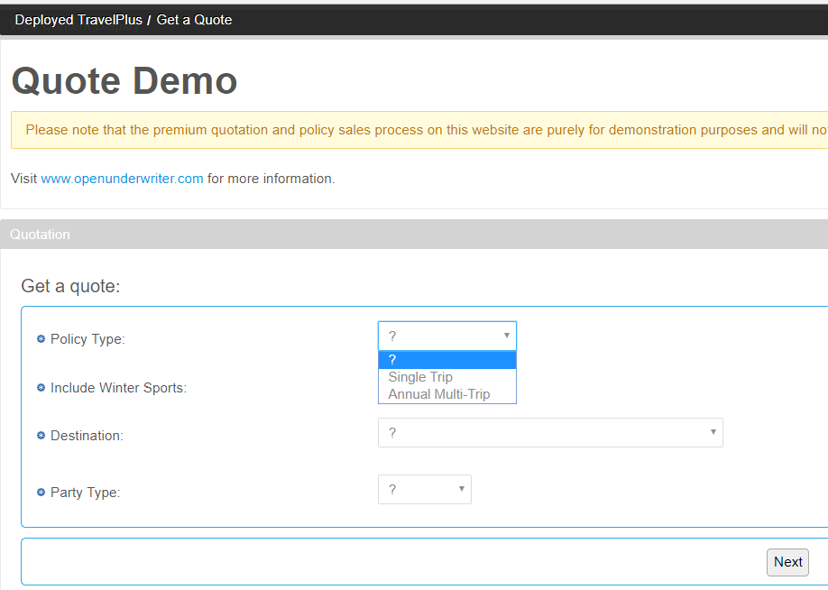

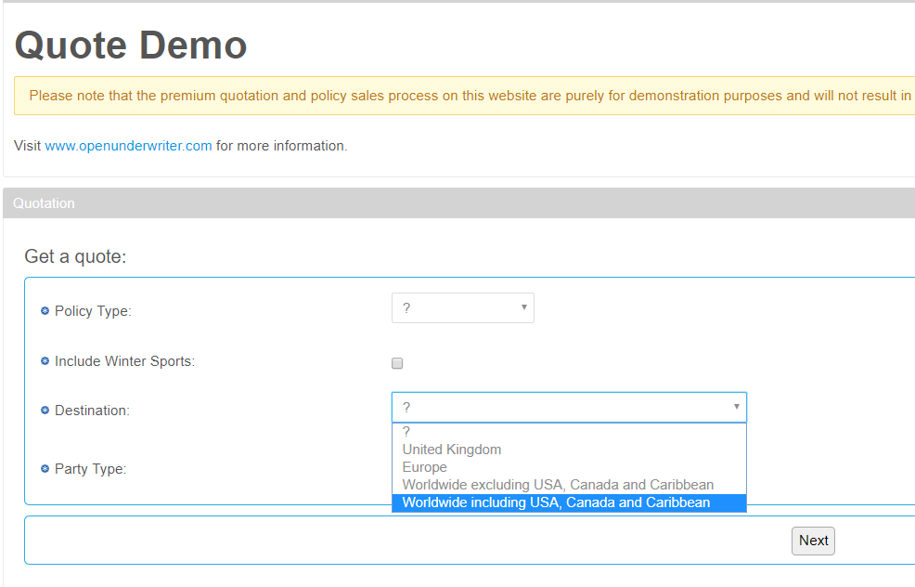

<http://localhost:8080/web/travelplus/get-a-quote>

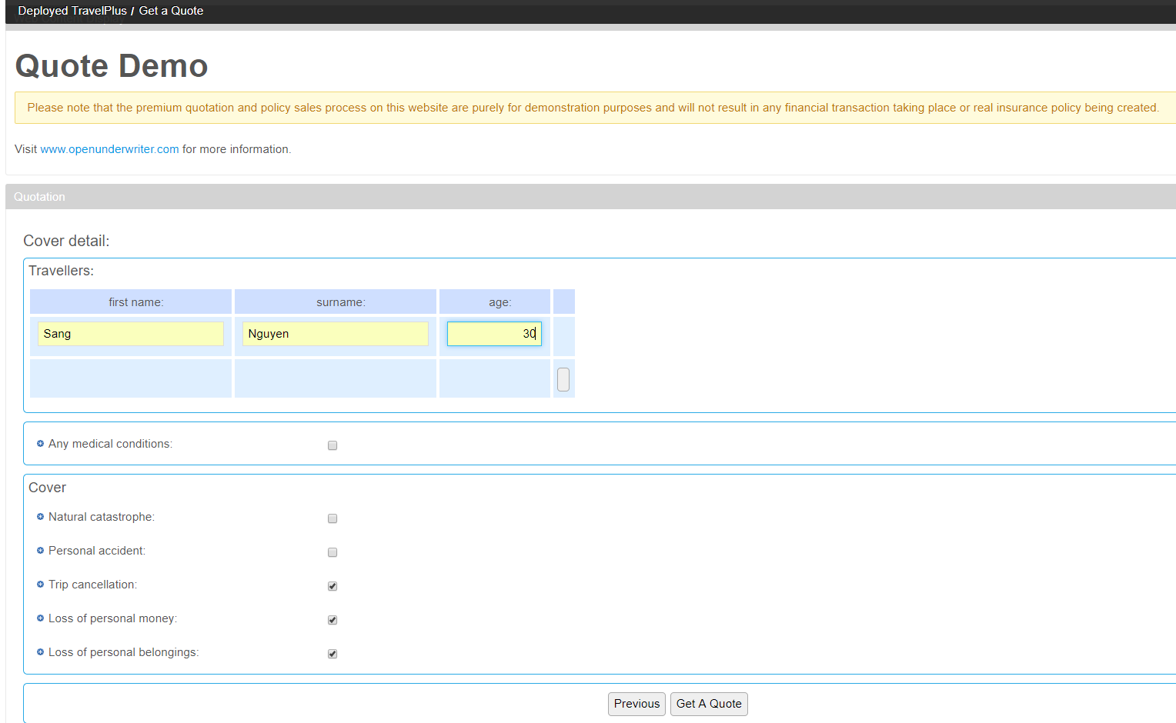

<http://localhost:8080/web/travelplus/get-a-quote>

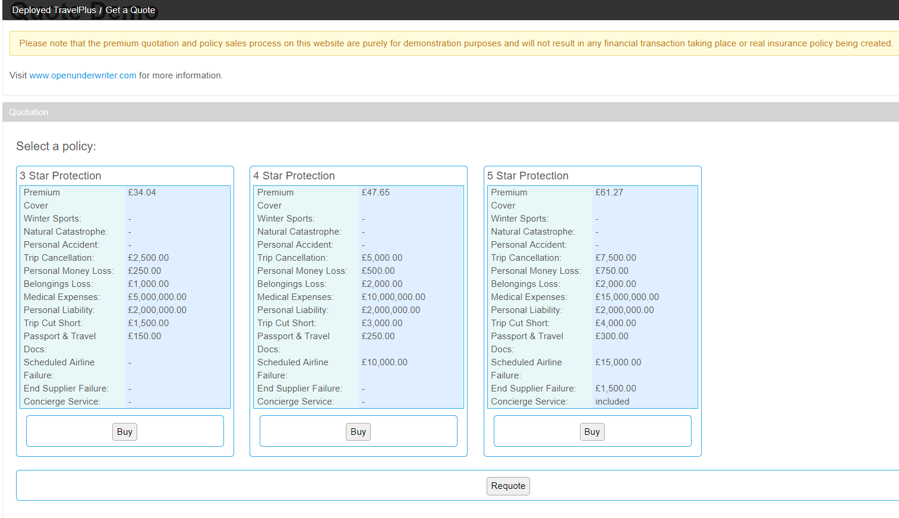

<http://localhost:8080/web/travelplus/get-a-quote>

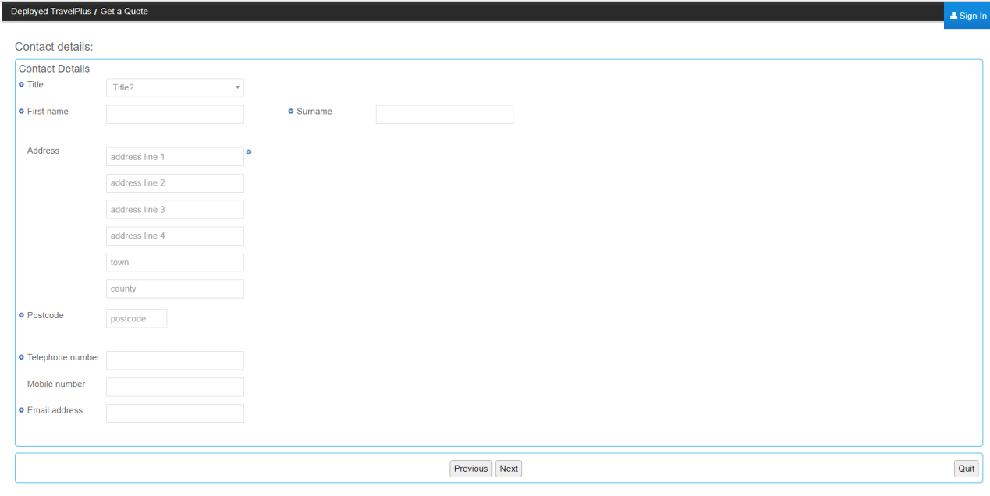

<http://localhost:8080/web/travelplus/get-a-quote>

